UNIT – 3: Python for Data Processing
3.1 Functional Python Programming
3.1.1 Lambda Functions and Their Utility
What Is Lambda Function ?
Lambda functions are anonymous, inline functions defined using the lambda keyword
Syntax
lambda arguments: expression
arguments = inputs to the function
expression = single output returned automatically
Example
1 ) square = lambda x: x ** 2
print(square(5))
# Output: 25

2 ) add = lambda a, b: a + b
print(add(3, 5))
# Output: 8

Difference Between Normal Function and Lambda Function

Feature | Normal Function | Lambda Function
Definition | Defined using the def keyword. | Defined using the lambda keyword.
Name | Has a name (e.g., def add():) | Anonymous (usually used without a name)
Use Case | Used for complex or reusable logic. | Used for short, one-time operations.
Readability | Easier to understand, especially for complex logic. | Less readable if overused or complex.
Return Statement | Requires an explicit return. | Implicitly returns the expression result.

Normal Function
def add(x, y):
return x + y
print(add(5, 3))
# Output: 8

Lambda Function
add = lambda x, y: x + y
print(add(5, 3))
# Output: 8

When to Use Which?
Use normal functions when:
- The logic is complex.
- You need to reuse or debug the function.
- You want better readability.
Use lambda functions when:
- You need a quick, one-line function (e.g., with map(), filter()).
- You don't need to reuse or name the function.

3.1.2 Map, Filter, and Reduce Functions for Efficient Data Processing
The map() function is used when you want to apply the same operation to every item in a data set model.

- It saves you from writing a loop, and it's especially helpful when processing large datasets during data cleaning or transformation.
- Makes your code shorter and more readable
- Avoids for-loops by applying a function to all items
- Helps in formatting, normalizing, or converting data types
- Often used in data pipelines and ETL (Extract, Transform, Load) steps
Syntax
map(function, iterable)
function: What to do to each item
iterable: A list, tuple, etc.
Applies a function to every item in an iterable.

Example
I want to double every number in my list.
nums = [1, 2, 3]
squares = list(map(lambda x: x ** 2, nums))
# Output: [1, 4, 9]

When to use map and when to use for loop ?
map() = cleaner, shorter, good for simple transformations
for loop = more powerful, better for complex tasks

Example: Multiply numbers by 2

Using map
numbers = [1, 2, 3, 4]
result = list(map(lambda x: x * 2, numbers))
print(result)
# Output: [2, 4, 6, 8]

using for loop
numbers = [1, 2, 3, 4]
result = []
for x in numbers:
result.append(x * 2)
print(result)
# Output: [2, 4, 6, 8]

Why list() is used around map() ?
If we not use list then ?
result = map(lambda x: x**2, [1, 2, 3])
print(result)
Output
<map object at 0x000001B7A...>
This is not a list, just a special object that stores results lazily (to save memory).

Other Collection Converters Like list()
Function | Converts to | Description | Example
list() | List | Converts iterable to a list (ordered, mutable) | list(map(...)) → [1, 2, 3]
tuple() | Tuple | Converts iterable to a tuple (ordered, immutable) | tuple(filter(...)) → (2, 4, 6)
set() | Set | Converts iterable to a set (unordered, unique elements) | set([1,2,2,3]) → {1, 2, 3}
dict() | Dictionary | Converts iterable of key-value pairs to a dict | dict([('a', 1), ('b', 2)]) → {'a': 1, 'b': 2}

filter(function, iterable)
The filter() function is used when you want to remove items from a list or iterable that do not meet a specific condition.
- It’s perfect for cleaning data by keeping only the valid or useful entries and ignoring the rest
- Helps clean up dirty data
- Removes missing, invalid, or irrelevant entries
- Makes downstream processing (e.g., training models) more accurate
- Keeps your code cleaner than using for loops
Syntax
filter(function, iterable)
function: What to do to each item
iterable: A list, tuple, etc.
Returns items from an iterable for which the function returns True.
Example
I only want the even numbers from my list.
nums = [1, 2, 3, 4]
evens = list(filter(lambda x: x % 2 == 0, nums))
# Output: [2, 4]

reduce(function, iterable)
The reduce() function is used when you want to combine all elements in a list into a single result — such as a total, product, maximum, or even a custom combination of values.
- you must import reduce() from the functools module.
- Takes a function and an iterable (like a list).
- The function must take two arguments.
- It applies the function to the first two elements, then to the result and the next element, and so on…
- Returns a single final value.
Syntax
reduce(function, iterable)
function: What to do to each item
iterable: A list, tuple, etc.

Example
#import library
from functools import reduce
# Function that adds two numbers
def add(x, y):
return x + y
numbers = [1, 2, 3, 4, 5]
result = reduce(add, numbers)
print(result)
# Output: 15

For Explain Its Working:
- add(1, 2) → 3
- add(3, 3) → 6
- add(6, 4) → 10
- add(10, 5) → 15

Question : If my Array like this then what happened
data = [True, "hello", "world"]

3.1.3 Using These Functions in Preprocessing Tasks
Using map() in Preprocessing
The map() function is used when you want to apply the same operation to every item in a data set model.

- It saves you from writing a loop, and it's especially helpful when processing large datasets during data cleaning or transformation.
- Makes your code shorter and more readable
- Avoids for-loops by applying a function to all items
- Helps in formatting, normalizing, or converting data types
- Often used in data pipelines and ETL (Extract, Transform, Load) steps

Example: Convert strings to integers
data = ['10', '20', '30']
converted = list(map(int, data))
# [10, 20, 30]

Example: Convert temperatures from Celsius to Fahrenheit
temps_c = [0, 20, 30]
temps_f = list(map(lambda c: c * 9/5 + 32, temps_c))
# [32.0, 68.0, 86.0]

Using filter() in Preprocessing
The filter() function is used when you want to remove items from a list or iterable that do not meet a specific condition.

- It’s perfect for cleaning data by keeping only the valid or useful entries and ignoring the rest
- Helps clean up dirty data
- Removes missing, invalid, or irrelevant entries
- Makes downstream processing (e.g., training models) more accurate
- Keeps your code cleaner than using for loops
Example
Datasets contain empty fields that you need to remove.
data = ['apple', '', 'banana', '', 'cherry']
cleaned = list(filter(lambda x: x != '', data))
# Output: ['apple', 'banana', 'cherry']

Example
You could also use bool(x) to remove any "falsy" values like '', None, or 0
data = ['apple', '', None, 'banana']
cleaned = list(filter(bool, data))
# Output: ['apple', 'banana']

Example
Keep Only Valid Emails
emails = ['user@example.com', '', 'not-an-email', 'admin@domain.com']
valid_emails = list(filter(lambda x: '@' in x and '.' in x, emails))
# Output: ['user@example.com', 'admin@domain.com']

Using reduce() in Preprocessing
The reduce() function is used when you want to combine all elements in a list into a single result — such as a total, product, maximum, or even a custom combination of values
- Unlike map() and filter(), you must import reduce() from the functools module
- To summarize or aggregate data
- To compress a dataset into a single value
- Makes your code cleaner than writing explicit loops
- Very helpful for calculating totals, finding extremes, or combining results

Example Calculate the Sum of Values
from functools import reduce
data = [10, 20, 30]
total = reduce(lambda x, y: x + y, data)
print(total)
# Output: 60

Example Find the Maximum or Minimum
data = [45, 72, 30, 99, 60]
maximum = reduce(lambda x, y: x if x > y else y, data)
print(maximum)
# Output: 99

Combined Example
from functools import reduce
data = ['10', '20', '', '30', 'not-a-number']

# Step 1: Filter out empty and non-numeric strings
cleaned = filter(lambda x: x.isdigit(), data)

# Step 2: Convert to integers
numbers = map(int, cleaned)

# Step 3: Sum the numbers
total = reduce(lambda x, y: x + y, numbers)

print(total)
# Output: 60
3.2 Comprehensions for Clean Code
In data processing and analysis, it's common to loop over data to filter, transform, or extract values
Python offers a powerful feature called comprehensions, which allow you to write concise (fewer lines and less repetition) and expressive (clear and easy to understand) code, replacing traditional for loops.
There are three main types:
- List comprehensions
- Dictionary comprehensions
- Set comprehensions

3.2.1 List and Dictionary Comprehensions
List Comprehensions :
A list comprehension allows you to create a new list by writing an expression inside square brackets with a for loop, and optionally an if condition.
- Quickly creates a new list by looping through an existing iterable (like a list or range).
- Allows filtering and transforming items in a single line of code.

Syntax :
[expression for item in iterable if condition]
expression: what you want to do with each item (e.g. x**2)
iterable: the source list or data you're looping through
condition (optional): a filter that keeps only items that match

1. Create a list of squares
squares = [x**2 for x in range(5)]
# Output: [0, 1, 4, 9, 16]

2. Filter even numbers
numbers = [1, 2, 3, 4, 5, 6]
evens = [x for x in numbers if x % 2 == 0]
# Output: [2, 4, 6]

3. Clean a list of strings and lower
names = [' Alice ', 'BOB', ' Eve']
cleaned = [name.strip().lower() for name in names]
# Output: ['alice', 'bob', 'eve']

Dictionary Comprehensions
Dictionary comprehensions work the same way as list comprehensions, but they create key-value pairs using curly braces {}.
- Quickly builds a dictionary by defining how to create keys and values from an iterable.
- Supports filtering and transformation of key-value pairs.

Syntax
{key: value for item in iterable if condition}
key : What you want to use as the key in the new dictionary
value : What you want to use as the value in the dictionary
iterable : The data you're looping through — usually a list, tuple, or dictionary
condition : A filter to include only certain items
Examples
Create a dictionary of squares
squares = {x: x**2 for x in range(5)}
# Output: {0: 0, 1: 1, 2: 4, 3: 9, 4: 16}

Filter and modify a dictionary
original = {'a': 1, 'b': 2, 'c': 3, 'd': 4}
filtered = {k: v*10 for k, v in original.items() if v % 2 == 0}
# Output: {'b': 20, 'd': 40}

3.2.2 Writing Compact Loops for Data Filtering and Transformation
Comprehensions allow you to write compact (small) loops that handle both filtering and transformation in a single line — making your code cleaner and easier to maintain

What Is Clean Code?
Clean code is:
- Easy to read and understand
- Simple and efficient
- Helps others (or your future self) understand your logic quickly

What Are Comprehensions?
Comprehensions are a one-line way to create new lists, sets, or dictionaries from existing data by applying filters and transformations.

Example 1: Filtering Only Even Numbers
numbers = [1, 2, 3, 4, 5, 6]
even_numbers = [n for n in numbers if n % 2 == 0]
print(even_numbers)
#output
[2, 4, 6]

Example 2: Transforming Names to Uppercase
names = ["virat", "rohit", "pant"]
upper_names = [name.upper() for name in names]
print(upper_names)
#output
[‘VIRAT’, ‘ROHIT’, ‘PANT’]

Example 3: Filter Students Who Passed and Add Bonus Marks
Problem: Select students with marks > 40 and give them 10 bonus marks.
students = [
{"name": "Rajat", "score": 38},
{"name": "Virat", "score": 45},
{"name": "Rohit", "score": 52},
]

passed = [
{"name": s["name"], "score": s["score"] + 10}
for s in students if s["score"] > 40
]
print(passed)

#output
[{'name': ' Virat', 'score': 55}, {'name': ' Rohit ', 'score': 62}]

3.3 Basics of Data Handling in Python

Pandas:
• It is a package useful for data analysis and manipulation.
• Pandas provide an easy way to create, manipulate and wrangle the data.
• Pandas provide powerful and easy-to-use data structures, as well as the means to quickly perform operations on these structures.

Data scientists use Pandas for its following advantages:
• Easily handles missing data.
• It uses Series for one-dimensional data structure and DataFrame for multi-dimensional data structure.
• It provides an efficient way to slice the data.
• It provides a flexible way to merge, concatenate or reshape the data.

DATA STRUCTURE IN PANDAS :
A data structure is a way to arrange the data in such a way that so it can be accessed quickly and we can perform various operation on this data like- retrieval, deletion, modification etc.

Pandas deals with 3 data structure
1. Series
2. Data Frame
3. Panel

Series -
Series is a one-dimensional array like structure with homogeneous data, which can be used to handle and manipulate data. What makes it special is its index attribute, which has incredible functionality and is heavily mutable.

It has two parts
1. Data part (An array of actual data)
2. Associated index with data (associated array of indexes or data labels)

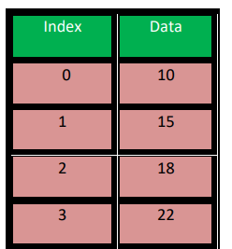

We can say that Series is a labeled one-dimensional array which can hold any type of data.
Data of Series is always mutable, means it can be changed.
But the size of Data of Series is always immutable, means it cannot be changed.
install pandas using
pip install pandas

check its install using this
import pandas as pd
print(pd.__version__)

#Print Values Using Series ------------------
import pandas as pd
a = [10, 20, 12]
newSeries = pd.Series(a)
print(newSeries)

#Find Specific Value ----------------------------------------------
import pandas as pd
a = [10, 20, 12]
newSeries = pd.Series(a)
print(newSeries[0])

#Manually Apply Index ----------------------------------------------
import pandas as pd
a = [10, 20, 12]
newSeries = pd.Series(a , index=['x','y','z'])
print(newSeries)

#Exapmle 2 ---------------------------------------
import pandas as pd
newSeries = pd.Series(50,index=[5, 1, 2, 3])
print(newSeries)

#Exapmle 3 ---------------------------------------
import pandas as pd
country=["ind","aus","nz"]
cost=[100,200,300]
newSeries= pd.Series(cost,index=country)
print(newSeries)

#Series From Dictionary ------------------
import pandas as pd
newDictionary= {'Name' : 'Hardik', 'Iplteam' : 'MI', 'Runs' : 1500}
newSeries = pd.Series(newDictionary)
print(newSeries)

#Exapmle 2 ---------------------------------------
import pandas as pd
calories = {"Name": 'Virat', "Iplteam": 'RCB', "Runs": 500}
newSeries = pd.Series(calories, index = ["Name", "Iplteam"])
print(newSeries)

-----------------------Mathematical Operations --------------------------------
import pandas as pd
s = pd.Series([1, 2, 3, 4, 5])
print('To Multiply all values in a series by 2')
print('------------------------------------------')
print(s * 2)

print('To Find the Square of all the values in a series')
print('------------------------------------------')
print(s ** 2)

print('To print all the values in a series that are greater than 2')
print('------------------------------------------')
print(s[s > 2])

import pandas as pd
s1 = pd.Series([1, 2, 3, 4, 5], index=['a', 'b', 'c', 'd', 'e'])
s2 = pd.Series([10, 20, 30, 40, 50], index=['a', 'b', 'c', 'd', 'e'])
s3 = pd.Series([5, 14, 23, 32], index=['a', 'b', 'c', 'd'])

print('To Add Series1 & Series2')
print('------------------------------------------')
print(s1 + s2)

print('To Add Series2 & Series3')
print('------------------------------------------')
print(s2 + s3)

print('To Add Series2 & Series3 and Fill Non-Matching Index with 0')
print('------------------------------------------')
print(s2.add(s3, fill_value=0))

-----------------------Head Tail Functions In Series --------------------------------
head (): It is used to access the first 5 rows of a series.
Note :To access first 3 rows we can call series_name.head(3)

import pandas as pd
# Create a Series directly from a list
s = pd.Series([10, 15, 18, 22, 55, 77, 42, 48, 97])

# To print first 5 rows
print("First 5 rows:")
print(s.head())

# To print first 3 rows
print("\nFirst 3 rows:")
print(s.head(3))

# To print last 5 rows
print("\nLast 5 rows:")
print(s.tail())

# To print last 3 rows
print("\nLast 3 rows:")
print(s.tail(3))

----------------------- Selection in Series --------------------------------
Series provides index label loc and iloc and [] to access rows and columns.

1. loc index label :-
Syntax:- series_name.loc[StartRange: StopRange]

Example
import pandas as pd
# Create a Series directly from a list
s = pd.Series([10, 15, 18, 22, 55, 77])
print(s)

# To print values from index 0 to 2
print(s.loc[:2])

# To print values from index 3 to 4
print(s.loc[3:4])

2. Selection Using iloc index label :-
Syntax:-series_name.iloc[StartRange : StopRange]

Example
import pandas as pd
# Create a Series directly from a list
s = pd.Series([10, 15, 18, 22, 55, 77])
print(s)

# To print values from index 0 to 1
print(s.iloc[:2])

# To print values from index 3 to 4
print(s.iloc[3:4])

3. Selection Using [] :
Syntax:-series_name[StartRange> : StopRange] or series_name[ index]

import pandas as pd
# Create a Series directly from a list
s = pd.Series([10, 15, 18, 22, 55, 77])
print(s)

# To print value at index 1
print(s[1])

# To print value at index 3
print(s[3:4])

# To print values from index 0 to 2
print(s[:3])

----------------------- Slicing in Series--------------------------------
Slicing is a way to retrieve subsets of data from a pandas object. A slice object
syntax is –
SERIES_NAME [start:end: step]
The segments start representing the first item, end representing the last item, and step representing the increment between each item that you would like

import pandas as pd

# Create a Series directly from a list with custom indexes
s = pd.Series([10, 15, 18, 22, 55, 77], index=['A', 'B', 'C', 'D', 'E', 'F'])
print(s)

# Print values from index positions 1 to 4 with a step of 2
print(s[1:5:2])

# Print values from index positions 0 to 5 with a step of 2
print(s[0:6:2])
Understanding Of loc and iloc (interger based index and normal index)
s = pd.Series(['a', 'b', 'c'], index=[10, 20, 30])
print(s)
print(s.iloc[0])
print(s.loc[0])

Question 1: What will this return?
import pandas as pd

s = pd.Series([100, 200, 300, 400], index=[10, 20, 30, 40])
print(s.iloc[1:3])

Question 2: What will this return?

s = pd.Series([10, 15, 18, 22, 55, 77])
print(s.loc[2:4])
print(s.iloc[2:4])

Question 3: What will this return?

s = pd.Series([10, 20, 30], index=[5, 3, 1])
print(s.loc[1])
print(s.iloc[1])

Question 4: What will this return?

s = pd.Series([7, 8, 9], index=['x', 'y', 'z'])
print(s.iloc['1'])

DATAFRAME -
It is a two-dimensional object that is useful in representing data in the form of rows and columns.
It is similar to a spreadsheet or an SQL table. This is the most commonly used pandas object.
Once we store the data into the Dataframe, we can perform various operations that are useful in analyzing and understanding the data.
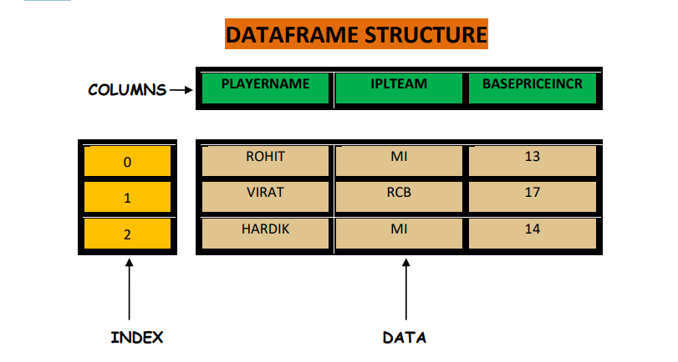

1. A Dataframe has axes (indices)- ➢ Row index (axis=0) ➢ Column index (axis=1)
2. It is similar to a spreadsheet , whose row index is called index and column index is called column name.
A data frame can be created using any of the following-
1. Series
2. Lists
3. Dictionary
4. A numpy 2D array

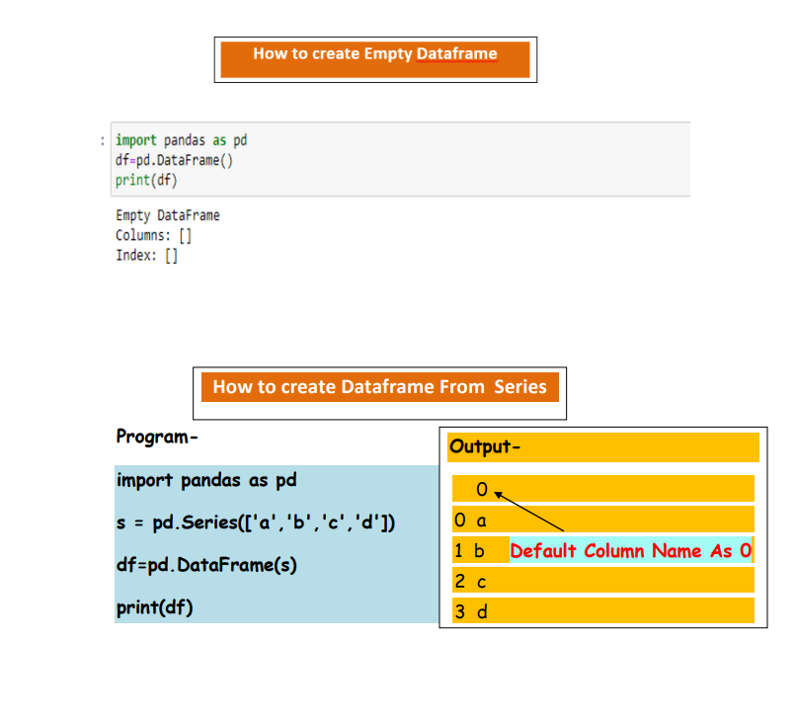
s = pd.Series(['a','b','c','d'])
df=pd.DataFrame(s)

Manually Set Column On Series Dataset
s = pd.Series(['shubh','amit','herry','hiren'])
df=pd.DataFrame(s, columns=['names'])
print(df)

Example
Import pandas as pd
std_data = [(1,'Aman','boAt'),
(2,'Deepinder','Zomato'),
(3,'Bhavish','Ola'),
(4,'Piyush','Lenskart'),
(5,'Vijay','Paytm')]

df = pd.DataFrame(std_data,columns=['id','name','company'])
print(df)
df.to_csv('mydata.csv', index=False)
df.read_csv(‘mydata.csv’)

---------------------------- DataFrame Operations ------------------------------------
import pandas as pd
std_data = [(1,'Aman',42,'boAt'),
(2,'Deepinder',38,'Zomato'),
(3,'Bhavish',45,'Ola'),
(4,'Piyush',49,'Lenskart'),
(5,'Vijay',30,'Paytm')]
df = pd.DataFrame(std_data,columns=['id','name','age','company'])
#select single column
df['name']
#select multiple columns
df[['name','company']]
#select single row
df.loc[0]
#select multiple row
df.loc[[0,1]]
#select row by integer index
df.iloc[[0,1]]

#filtering rows
df[df['age'] > 44]

#adding new column
df['phone']=[1234,5678,9101,11213,1234]
df['phone']=12345

#add column at specific location
df.insert(1,'phone',12345)

#rename column name
df.rename(columns={'phone':'mobile'},inplace=True)

#delete column
del df['company']

#drop column
df = df.drop(2)

#adding new row in dataframe
df.loc[1] = [2,'harsh',27,'salon']

#updating the values 2 is index
df.loc[2,'age'] = 28

#update multiple age
#df.loc[[0,1],'age'] =25

